

Automated In-Plant Line Inspection Reporting System

**USER’S MANUAL**

( POSMD Account )

Process Owner:

**Plant Operation Standards and Monitoring Division**

Prepared by:

**NMIS System Development Team**

TABLE OF Contents

Login Page 3

Dashboard 5

Plant operation Standard and Monitoring Section 6

Meat inspection Profile 7

# Login Page

STEP 1: By accessing <http://localhost/AIPLIRSnative/pages/auth/index.php>

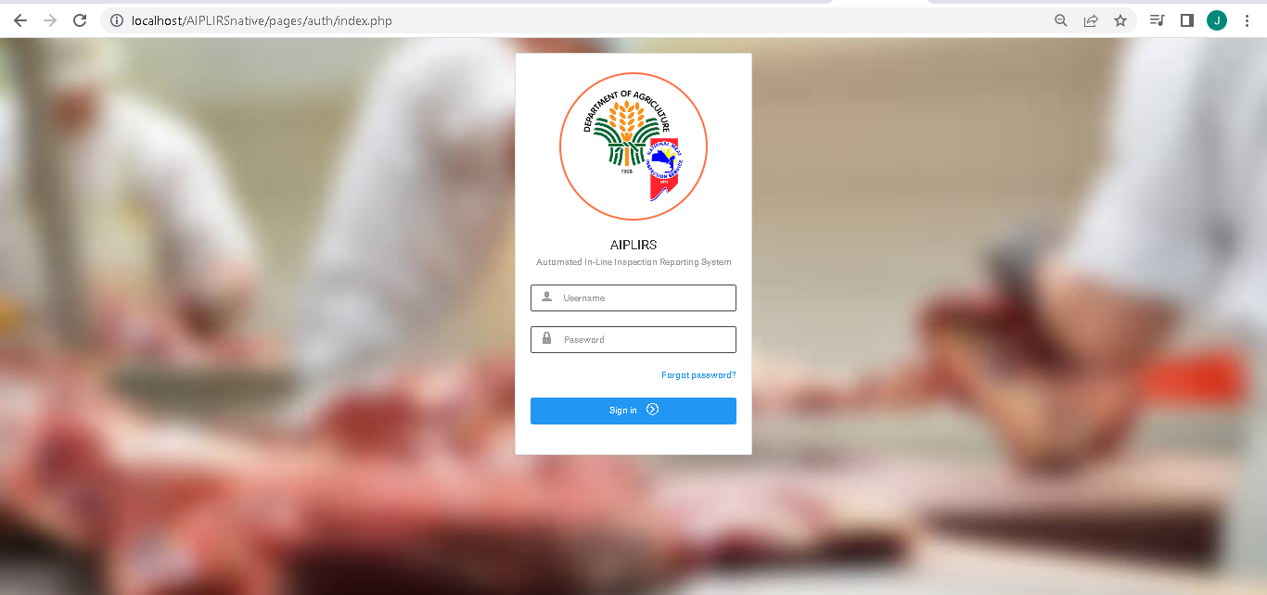

Step 2: Input your credentials (Username / Password)

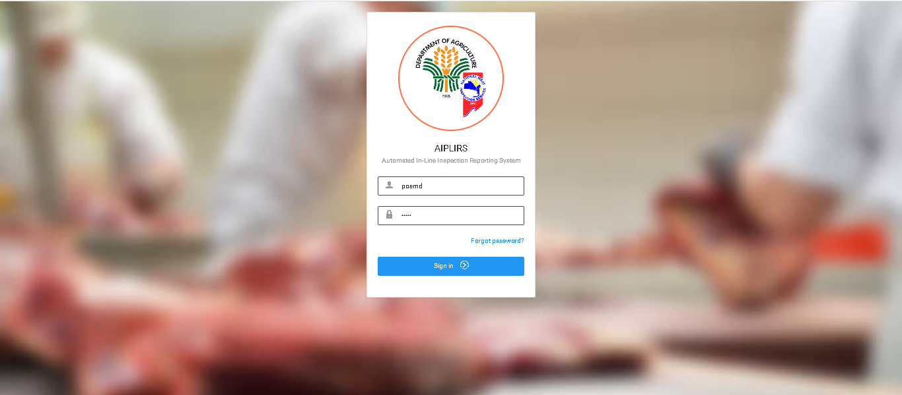

Step 3: if username and password is incorrect prompt will flash a message

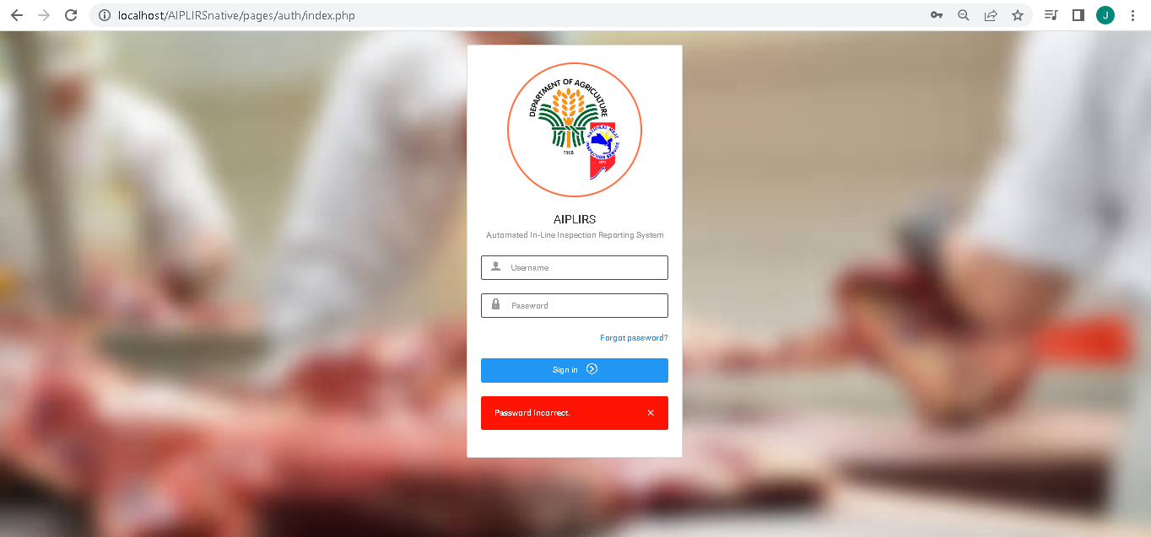

Step 4: if Successful system will redirected user to dashboard.

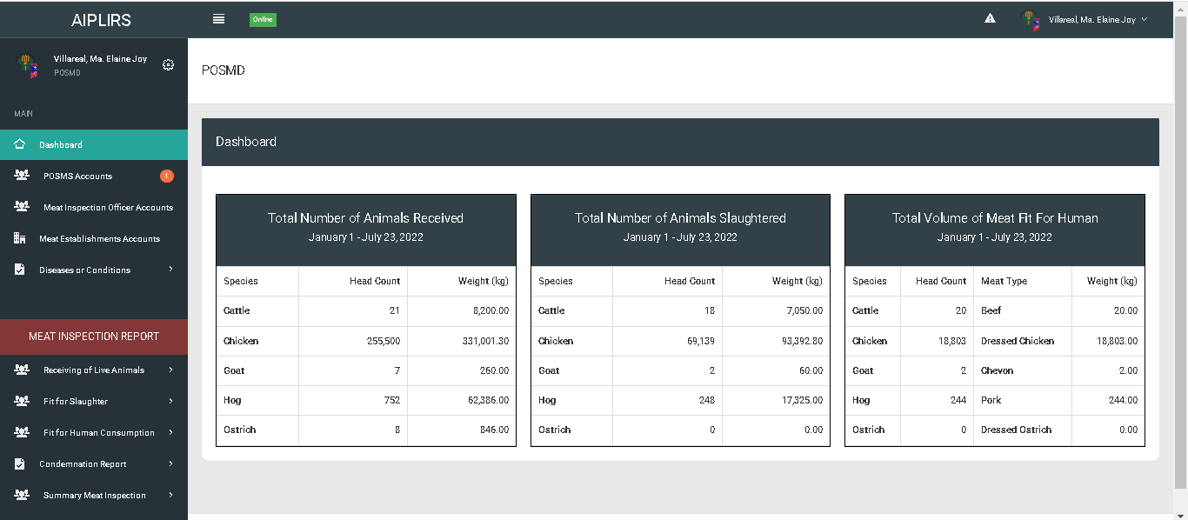

# Dashboard

1: Dashboard: Page Buttons

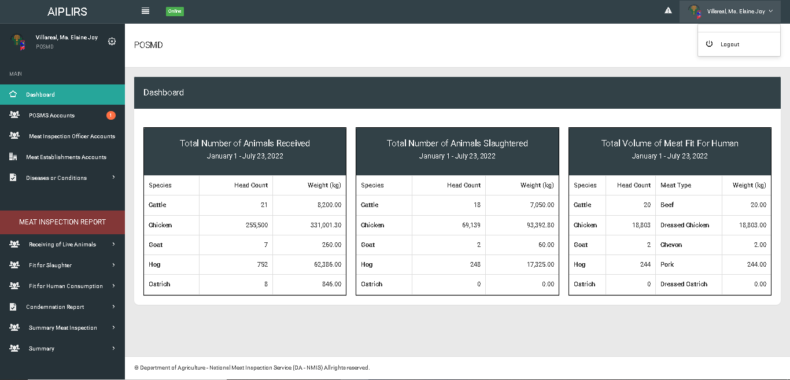

Summary from January 1

System Name

Sidebar

# Plant operation Standard and Monitoring Section Accounts

1: POSMS Accounts: This page is listed all the POSMS accounts and some status and Actions

Account Status:

* **Email not Activated**: Upon registration user must be activate their email.
* **Pending:** After activating their account the account status will update to “Pending”.
* **Active:** This is the indicator for the POSMS, POSMD if account is active .on system to proceed in another process.
* **Rejected:** This account status declaring that the applicant is rejected.
* **Deactivated:** This indicates that the account is deactivated some reason (Resigned, Violates rule).

Actions:

* **Email not Activated**: Upon registration user must be activate their email.
* **Approve**: This action is to approve the application to operate the system
* **Disapproved**: This action is to reject application if account is not is a part of posms
* **Activate**: This action is setting the account from deactivated to active
* **Deactivate**: This action is setting the account from active to deactivated.

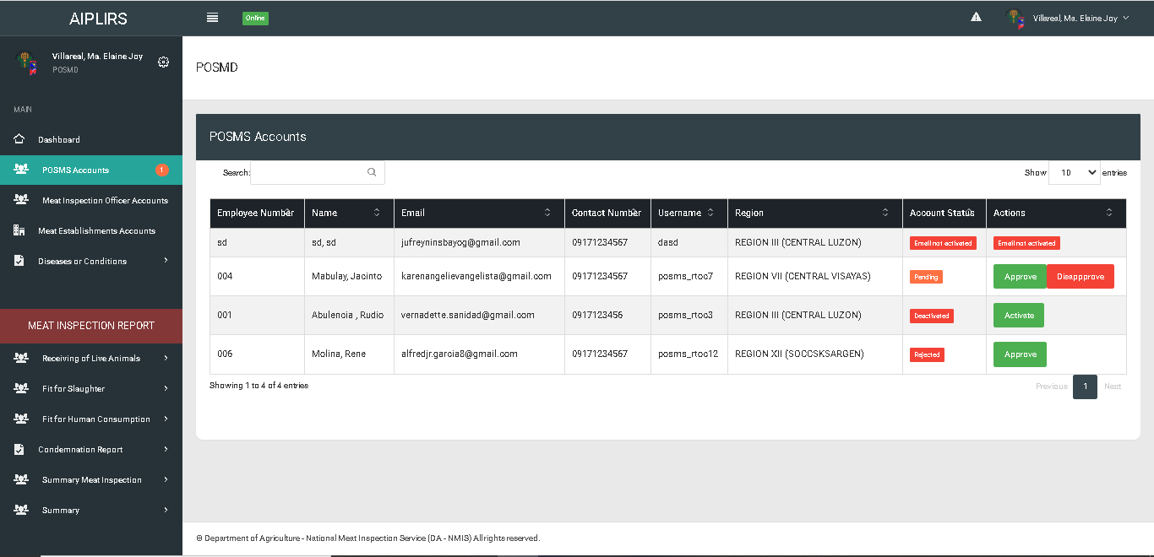

# Meat inspection officer accounts

On Meat Inspection Officer page, you will see the list of meat inspection officer in all regions with their details region assign

On meat inspection officer page has “view details” button. After clicking this button system will be redirected you to another page which indicates all the information about what MIO you select (Meat Inspection Profile, Meat establishment assignments, Previous Meat establishment assign, Meat Inspection Activities).

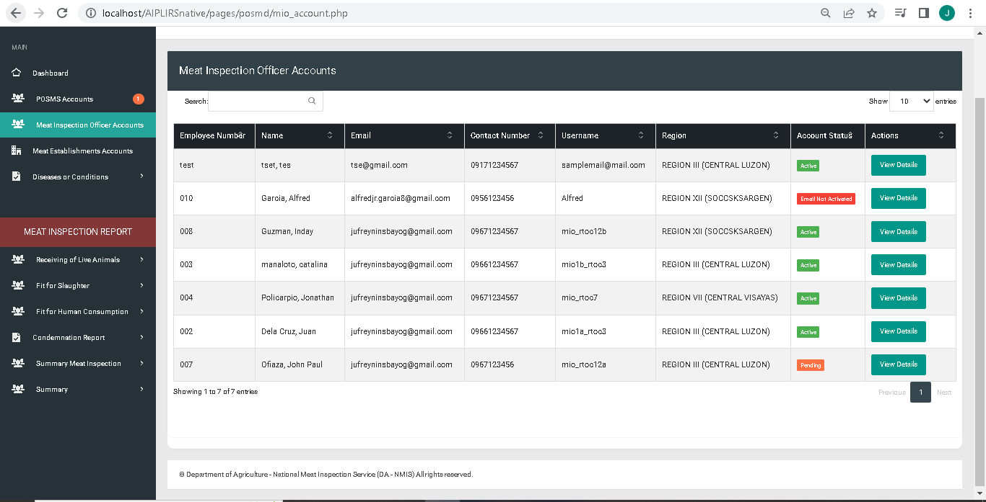

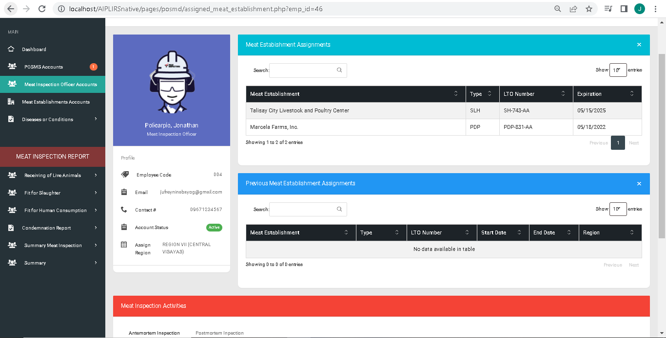

Current ME Assignment



Meat inspection Officer Profile



Previous assignment

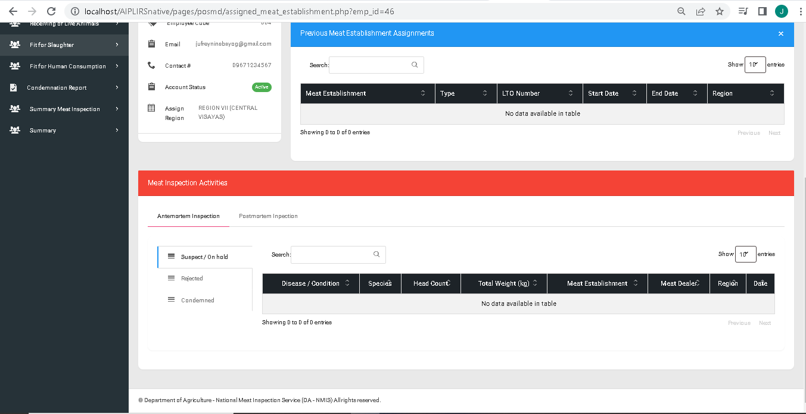

All activities conduction by MIO

**Meat Establishment Profile**

**Diseases or Conditions**

**Receiving of Live Animals**

**Fit for Slaughter**

**Fit for Human Consumption**

**Condemnation Report**

**Summary Meat Inspecion Report**

**Summary**